Supplementary Material

Table S1. Additional patient characteristics.
Patient | A | B | C | D | E | F | G | H
Seizure phenotype | Tonic | GTC | Focal | Mixed | GTC | Focal | Focal | Tonic
Number of previously used AEDs | 3 | 2 | 5 | 8 | 7 | 4 | 7 | 2
Secondary effects due to AEDs | Cytotoxic edema in mesencephalo pale globe and thalamus (vigabatrin), drowsiness (zonisamide) | - | - | Liver toxicity (valproic acid), hyper-  ammonemia (topiramate) | - | Drowsiness (vigabatrin), thrombocytepenia, macrocytosis, hypertransaminasemia (valproic acid) | - | -
Nutritional rout | Oral | NG-tube | G-tube | Oral | Oral | Oral | Oral | Oral
KDT early side effects | - | - | HG, HTG | C | - | HC | - | HG, HTG
KDT late side effects | HCHO, HTG, P | HTG, HC, P | HCHO | C, ↑GGT levels | HCHO | HC, P, HCHO, ↑GGT levels | - | HCHO, hypo-citraturia, P
GTC: generalized tonic-clonic seizures. AEDs: antiepileptic drugs. KDT: ketogenic dietary therapies. NG-tube: nasogastric tube. G-tube: gastrostomy tube. HTG: hypertriglyceridemia, HC: Hipercalciuria, HCHO: Hypercholesterolemia, P: Proteinuria, C: constipation, GGT: gamma-glutamyl transferase.

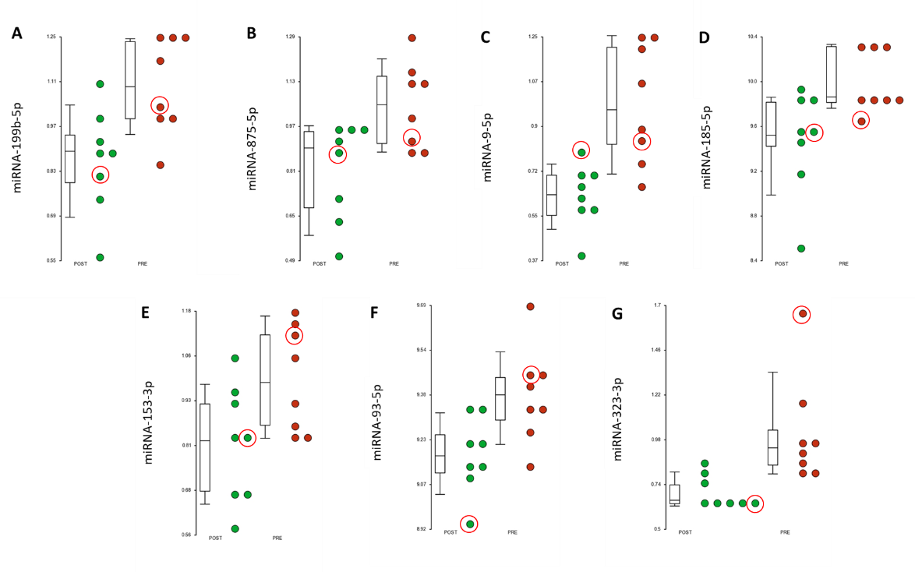
Fig. S1. Differentially-expressed miRNAs selected in the combine analysis and which regulate CNS genes. Box and dots with the individual level of expression are represented. Green dots are samples pre-treatment and red dot post-treatment with KD. (A) miR-199-5-p; (B) miR-875-5p; (C) miR-9-5p; (D) miR-185-5p; (E) miR-153-5p; (F) miR-93-5p; (G) miR-323-5p. Dots surrounded by a red circle correspond to patient E, whose number of epileptic seizures did not decrease although they were of less intensity and duration during the ketogenic diet treatment.

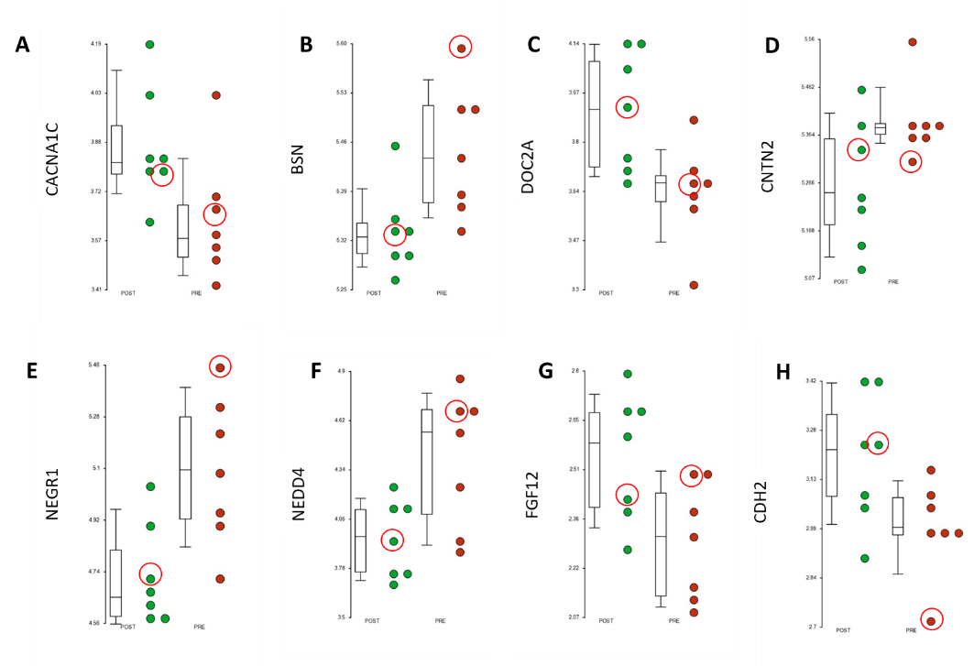
Fig. S2. Differentially-expressed genes related to CNS and regulated by the miRNAs selected in the combine analysis. Box and dots with the individual level of expression are represented. Green dots are samples pre-treatment and red dot post-treatment with KD. (A) CACNA1C; (B) BSN; (C) DOC2A; (D) CNTN2; (E) NEGR1; (F) NEDD4; (G) FGF12; (H) CDH2. Dots surrounded by a red circle correspond to patient E, whose number of epileptic seizures did not decrease although they were of less intensity and duration during the ketogenic diet treatment.

Table S2. miRNAs and genes regulated by them whose expression changes after the treatment with KD.
Transcript ID (Array Design) | p-value (POST vs. PRE) | Fold-Change (POST vs. PRE) | Gene Symbol | p-value (POST vs. PRE) | Fold-Change (POST vs. PRE)
hsa-miR-323a-3p | 0,00947198 | -1,25528 | AC026703.1 | 0,00401866 | 1,13747
hsa-miR-130a-3p | 0,0455117 | -1,32703 | AGO1 | 0,0367393 | -1,18457
hsa-miR-136-5p | 0,0493858 | -1,13125 | AGO1 | 0,0367393 | -1,18457
hsa-miR-153-3p | 0,035485 | -1,13427 | AGO1 | 0,0367393 | -1,18457
hsa-miR-185-5p | 0,0170276 | -1,43938 | AGO1 | 0,0367393 | -1,18457
hsa-miR-199b-5p | 0,0117981 | -1,17393 | AGO1 | 0,0367393 | -1,18457
hsa-miR-323a-3p | 0,00947198 | -1,25528 | AGO1 | 0,0367393 | -1,18457
hsa-miR-93-5p | 0,014528 | -1,15902 | AGO1 | 0,0367393 | -1,18457
hsa-mir-378f | 0,00381327 | -1,27797 | AGO1 | 0,0367393 | -1,18457
hsa-miR-330-5p | 0,0129083 | 1,32685 | ALOX15B | 0,0108123 | -1,29243
hsa-miR-330-5p | 0,0129083 | 1,32685 | ANKRD13B | 0,0458106 | 1,151
hsa-miR-199b-5p | 0,0117981 | -1,17393 | AQP11 | 0,0490875 | 1,12089
hsa-miR-875-5p | 0,0159549 | -1,17831 | AQP11 | 0,0490875 | 1,12089
hsa-miR-9-5p | 0,00206558 | -1,28984 | ARHGAP39 | 0,00387989 | -1,29677
hsa-miR-9-5p | 0,00206558 | -1,28984 | ARPP21 | 0,0130023 | -1,34866
hsa-miR-130a-3p | 0,0455117 | -1,32703 | ATG16L1 | 0,0246607 | 1,20443
hsa-miR-93-5p | 0,014528 | -1,15902 | ATG16L1 | 0,0246607 | 1,20443
hsa-miR-130a-3p | 0,0455117 | -1,32703 | ATXN2 | 0,0480745 | -1,13303
hsa-miR-130a-3p | 0,0455117 | -1,32703 | BIRC6 | 0,0145791 | -1,26762
hsa-miR-153-3p | 0,035485 | -1,13427 | BSN | 0,020132 | -1,08424
hsa-miR-185-5p | 0,0170276 | -1,43938 | BSN | 0,020132 | -1,08424
hsa-miR-147b | 0,0106526 | 1,17269 | C11orf87 | 0,0193193 | 1,17137
hsa-miR-136-5p | 0,0493858 | -1,13125 | C18orf32 | 0,0160893 | -1,20311
hsa-miR-153-3p | 0,035485 | -1,13427 | C9orf40 | 0,020102 | 1,32995
hsa-miR-199b-5p | 0,0117981 | -1,17393 | CABP7 | 0,00667521 | 1,28288
hsa-miR-323a-3p | 0,00947198 | -1,25528 | CABP7 | 0,00667521 | 1,28288
hsa-miR-153-3p | 0,035485 | -1,13427 | CACNA1C | 0,0376877 | 1,18343
hsa-miR-323a-3p | 0,00947198 | -1,25528 | CACNA1C | 0,0376877 | 1,18343
hsa-miR-130a-3p | 0,0455117 | -1,32703 | CCDC9 | 0,00468811 | 1,35049
hsa-miR-185-5p | 0,0170276 | -1,43938 | CCDC9 | 0,00468811 | 1,35049
hsa-miR-199b-5p | 0,0117981 | -1,17393 | CDH2 | 0,0470869 | 1,14996
hsa-miR-199b-5p | 0,0117981 | -1,17393 | CHN2 | 0,0206448 | 1,19551
hsa-miR-130a-3p | 0,0455117 | -1,32703 | CHST11 | 0,0338616 | -1,17999
hsa-miR-185-5p | 0,0170276 | -1,43938 | CHST11 | 0,0338616 | -1,17999
hsa-miR-153-3p | 0,035485 | -1,13427 | CLMP | 0,00065218 | -1,22897
hsa-miR-9-5p | 0,00206558 | -1,28984 | CNNM1 | 0,0398478 | -1,19679
hsa-miR-185-5p | 0,0170276 | -1,43938 | CNTN2 | 0,0412131 | -1,09656
hsa-miR-9-5p | 0,00206558 | -1,28984 | CPT1A | 1,00E-05 | 1,61967
hsa-miR-199b-5p | 0,0117981 | -1,17393 | CYLC2 | 0,0439305 | 1,16874
hsa-miR-153-3p | 0,035485 | -1,13427 | DLGAP2 | 0,0196769 | -1,20649
hsa-miR-330-5p | 0,0129083 | 1,32685 | DLGAP2 | 0,0196769 | -1,20649
hsa-miR-9-5p | 0,00206558 | -1,28984 | DLGAP2 | 0,0196769 | -1,20649
hsa-miR-93-5p | 0,014528 | -1,15902 | DLGAP2 | 0,0196769 | -1,20649
hsa-miR-153-3p | 0,035485 | -1,13427 | DOC2A | 0,0202805 | 1,20986
hsa-miR-9-5p | 0,00206558 | -1,28984 | EPAS1 | 0,0154966 | -1,18171
hsa-miR-93-5p | 0,014528 | -1,15902 | EPAS1 | 0,0154966 | -1,18171
hsa-miR-130a-3p | 0,0455117 | -1,32703 | FAM155A | 0,0304214 | 1,14201
hsa-miR-185-5p | 0,0170276 | -1,43938 | FAM53C | 0,0482149 | -1,23035
hsa-miR-330-5p | 0,0129083 | 1,32685 | FAM53C | 0,0482149 | -1,23035
hsa-miR-153-3p | 0,035485 | -1,13427 | FBXO32 | 0,0404317 | 1,20914
hsa-miR-330-5p | 0,0129083 | 1,32685 | FCRLB | 0,0239561 | -1,12097
hsa-mir-378f | 0,00381327 | -1,27797 | FCRLB | 0,0239561 | -1,12097
hsa-miR-9-5p | 0,00206558 | -1,28984 | FGF12 | 0,0265731 | 1,1931
hsa-miR-93-5p | 0,014528 | -1,15902 | FGF12 | 0,0265731 | 1,1931
hsa-miR-9-5p | 0,00206558 | -1,28984 | FKBP7 | 0,0206536 | -1,2861
hsa-miR-136-5p | 0,0493858 | -1,13125 | FRK | 0,0498251 | -1,20291
hsa-miR-153-3p | 0,035485 | -1,13427 | FRK | 0,0498251 | -1,20291
hsa-miR-185-5p | 0,0170276 | -1,43938 | FRK | 0,0498251 | -1,20291
hsa-miR-93-5p | 0,014528 | -1,15902 | FRK | 0,0498251 | -1,20291
hsa-miR-9-5p | 0,00206558 | -1,28984 | GALNT16 | 0,0431856 | -1,1775
hsa-miR-93-5p | 0,014528 | -1,15902 | GMPR | 0,0172953 | 1,20674
hsa-miR-130a-3p | 0,0455117 | -1,32703 | GPC6 | 0,0284538 | -1,1349
hsa-miR-136-5p | 0,0493858 | -1,13125 | GPC6 | 0,0284538 | -1,1349
hsa-miR-9-5p | 0,00206558 | -1,28984 | GPC6 | 0,0284538 | -1,1349
hsa-miR-93-5p | 0,014528 | -1,15902 | GPC6 | 0,0284538 | -1,1349
hsa-miR-199b-5p | 0,0117981 | -1,17393 | GPR63 | 0,0495725 | -1,24426
hsa-miR-93-5p | 0,014528 | -1,15902 | GPR63 | 0,0495725 | -1,24426
hsa-miR-153-3p | 0,035485 | -1,13427 | HERC3 | 0,00779769 | 1,243
hsa-miR-330-5p | 0,0129083 | 1,32685 | HEYL | 0,00724727 | -1,10881
hsa-miR-551a | 0,0229619 | 1,17296 | HEYL | 0,00724727 | -1,10881
hsa-miR-199b-5p | 0,0117981 | -1,17393 | HOXA7 | 0,0324385 | 1,12024
hsa-miR-130a-3p | 0,0455117 | -1,32703 | IL1RAP | 0,0193879 | -1,49978
hsa-miR-130a-3p | 0,0455117 | -1,32703 | IL1RAP | 0,0280605 | -1,21245
hsa-miR-93-5p | 0,014528 | -1,15902 | IL1RAP | 0,0193879 | -1,49978
hsa-miR-93-5p | 0,014528 | -1,15902 | IL1RAP | 0,0280605 | -1,21245
hsa-miR-875-5p | 0,0159549 | -1,17831 | ITGBL1 | 0,0472348 | -1,08284
hsa-miR-130a-3p | 0,0455117 | -1,32703 | KIAA1217 | 0,0106903 | -1,17921
hsa-miR-9-5p | 0,00206558 | -1,28984 | KIAA1217 | 0,0106903 | -1,17921
hsa-miR-130a-3p | 0,0455117 | -1,32703 | MAFB | 0,0399291 | -1,86703
hsa-miR-185-5p | 0,0170276 | -1,43938 | MSI1 | 0,0181101 | -1,32573
hsa-miR-136-5p | 0,0493858 | -1,13125 | NANOS1 | 0,0252146 | 1,2433
hsa-miR-93-5p | 0,014528 | -1,15902 | NANOS1 | 0,0252146 | 1,2433
hsa-miR-9-5p | 0,00206558 | -1,28984 | NEDD4 | 0,0190021 | -1,38042
hsa-miR-875-5p | 0,0159549 | -1,17831 | NEGR1 | 0,010135 | -1,29757
hsa-miR-199b-5p | 0,0117981 | -1,17393 | NINL | 0,0448515 | -1,10892
hsa-miR-323a-3p | 0,00947198 | -1,25528 | NPPC | 0,0391244 | -1,17995
hsa-miR-323a-3p | 0,00947198 | -1,25528 | NPR3 | 0,00160723 | -1,35729
hsa-miR-130a-3p | 0,0455117 | -1,32703 | NRARP | 0,0289041 | -1,13525
hsa-miR-153-3p | 0,035485 | -1,13427 | NRARP | 0,0289041 | -1,13525
hsa-miR-199b-5p | 0,0117981 | -1,17393 | NTNG1 | 0,0189638 | 1,26525
hsa-miR-9-5p | 0,00206558 | -1,28984 | NTNG1 | 0,0189638 | 1,26525
hsa-miR-93-5p | 0,014528 | -1,15902 | NTNG1 | 0,0189638 | 1,26525
hsa-miR-130a-3p | 0,0455117 | -1,32703 | NUFIP2 | 0,0422269 | -1,28912
hsa-miR-153-3p | 0,035485 | -1,13427 | NUFIP2 | 0,0422269 | -1,28912
hsa-miR-199b-5p | 0,0117981 | -1,17393 | NUFIP2 | 0,0422269 | -1,28912
hsa-miR-875-5p | 0,0159549 | -1,17831 | NUFIP2 | 0,0422269 | -1,28912
hsa-miR-93-5p | 0,014528 | -1,15902 | NUFIP2 | 0,0422269 | -1,28912
hsa-mir-378f | 0,00381327 | -1,27797 | NUFIP2 | 0,0422269 | -1,28912
hsa-miR-330-5p | 0,0129083 | 1,32685 | PABPC1L2A | 0,0251631 | -1,20072
hsa-miR-330-5p | 0,0129083 | 1,32685 | PABPC1L2B | 0,0213245 | -1,18619
hsa-miR-330-5p | 0,0129083 | 1,32685 | PADI1 | 0,0193319 | -1,2947
hsa-miR-875-5p | 0,0159549 | -1,17831 | PAPOLG | 0,00071048 | 1,20219
hsa-mir-378f | 0,00381327 | -1,27797 | PAPOLG | 0,00071048 | 1,20219
hsa-miR-199b-5p | 0,0117981 | -1,17393 | PARP12 | 0,0112623 | -1,19338
hsa-miR-130a-3p | 0,0455117 | -1,32703 | PFN2 | 0,0470315 | 1,17046
hsa-miR-93-5p | 0,014528 | -1,15902 | PFN2 | 0,0470315 | 1,17046
hsa-miR-9-5p | 0,00206558 | -1,28984 | PHF19 | 0,0384309 | -1,16973
hsa-miR-130a-3p | 0,0455117 | -1,32703 | PIK3CB | 0,0424201 | -1,07683
hsa-miR-9-5p | 0,00206558 | -1,28984 | PIK3CB | 0,0424201 | -1,07683
hsa-miR-136-5p | 0,0493858 | -1,13125 | PLXNB1 | 0,0088814 | -1,37048
hsa-miR-199b-5p | 0,0117981 | -1,17393 | PLXNB1 | 0,0088814 | -1,37048
hsa-miR-330-5p | 0,0129083 | 1,32685 | PLXNB1 | 0,0088814 | -1,37048
hsa-miR-875-5p | 0,0159549 | -1,17831 | PPM1E | 0,0366049 | 1,11105
hsa-miR-130a-3p | 0,0455117 | -1,32703 | PSD | 0,0302474 | -1,23175
hsa-miR-93-5p | 0,014528 | -1,15902 | PSD | 0,0302474 | -1,23175
hsa-miR-130a-3p | 0,0455117 | -1,32703 | PTGFRN | 0,0241209 | -1,15258
hsa-miR-153-3p | 0,035485 | -1,13427 | PTGFRN | 0,0241209 | -1,15258
hsa-miR-9-5p | 0,00206558 | -1,28984 | PTGFRN | 0,0241209 | -1,15258
hsa-miR-93-5p | 0,014528 | -1,15902 | PTGFRN | 0,0241209 | -1,15258
hsa-mir-378f | 0,00381327 | -1,27797 | RAB11A | 0,00879273 | 1,17252
hsa-miR-9-5p | 0,00206558 | -1,28984 | RASD2 | 0,0490693 | -1,13623
hsa-miR-93-5p | 0,014528 | -1,15902 | RGL1 | 0,0270895 | -1,2843
hsa-miR-9-5p | 0,00206558 | -1,28984 | SHC2 | 0,0070725 | -1,2385
hsa-miR-136-5p | 0,0493858 | -1,13125 | SHISA9 | 0,0330717 | -1,20063
hsa-miR-130a-3p | 0,0455117 | -1,32703 | SIX4 | 0,0230561 | 1,16638
hsa-miR-9-5p | 0,00206558 | -1,28984 | SIX4 | 0,0230561 | 1,16638
hsa-miR-93-5p | 0,014528 | -1,15902 | SLC16A12 | 0,0488575 | -1,08504
hsa-miR-93-5p | 0,014528 | -1,15902 | SLC2A4 | 0,00265521 | -1,26455
hsa-miR-153-3p | 0,035485 | -1,13427 | SMIM13 | 0,026134 | -1,15345
hsa-miR-199b-5p | 0,0117981 | -1,17393 | SRGAP3 | 0,049715 | -1,23149
hsa-miR-330-5p | 0,0129083 | 1,32685 | SRGAP3 | 0,049715 | -1,23149
hsa-miR-9-5p | 0,00206558 | -1,28984 | SRGAP3 | 0,049715 | -1,23149
hsa-miR-93-5p | 0,014528 | -1,15902 | SRGAP3 | 0,049715 | -1,23149
hsa-miR-199b-5p | 0,0117981 | -1,17393 | SRRM1 | 0,0366267 | -1,12878
hsa-miR-199b-5p | 0,0117981 | -1,17393 | STRADB | 0,029041 | -1,30831
hsa-miR-130a-3p | 0,0455117 | -1,32703 | TAF4 | 0,0125064 | -1,10618
hsa-miR-153-3p | 0,035485 | -1,13427 | TAF4 | 0,0125064 | -1,10618
hsa-miR-130a-3p | 0,0455117 | -1,32703 | TBCEL | 0,025494 | -1,09038
hsa-miR-136-5p | 0,0493858 | -1,13125 | TBCEL | 0,025494 | -1,09038
hsa-miR-9-5p | 0,00206558 | -1,28984 | TBCEL | 0,025494 | -1,09038
hsa-miR-93-5p | 0,014528 | -1,15902 | TBCEL | 0,025494 | -1,09038
hsa-miR-185-5p | 0,0170276 | -1,43938 | TBX19 | 0,0150349 | -1,27267
hsa-miR-130a-3p | 0,0455117 | -1,32703 | TEX2 | 0,00754846 | -1,23237
hsa-miR-9-5p | 0,00206558 | -1,28984 | TGM2 | 0,0478423 | -1,15345
hsa-miR-9-5p | 0,00206558 | -1,28984 | TMEM200C | 0,00148077 | -1,33746
hsa-miR-93-5p | 0,014528 | -1,15902 | TMEM200C | 0,00148077 | -1,33746
hsa-miR-9-5p | 0,00206558 | -1,28984 | TMEM38A | 0,0116572 | 1,27077
hsa-miR-130a-3p | 0,0455117 | -1,32703 | TMEM55B | 0,0226624 | -1,22692
hsa-miR-93-5p | 0,014528 | -1,15902 | TNFAIP1 | 0,00447613 | 1,14483
hsa-miR-9-5p | 0,00206558 | -1,28984 | TNFAIP8L3 | 0,0208492 | -1,12091
hsa-miR-9-5p | 0,00206558 | -1,28984 | TNS1 | 0,0281454 | -1,16188
hsa-miR-93-5p | 0,014528 | -1,15902 | TNS1 | 0,0281454 | -1,16188
hsa-miR-185-5p | 0,0170276 | -1,43938 | TOX3 | 0,0304009 | -1,3431
hsa-miR-199b-5p | 0,0117981 | -1,17393 | TOX3 | 0,0304009 | -1,3431
hsa-miR-136-5p | 0,0493858 | -1,13125 | TPRG1 | 0,0495091 | -1,48846
hsa-miR-153-3p | 0,035485 | -1,13427 | TRIO | 0,0348153 | 1,14813
hsa-miR-330-5p | 0,0129083 | 1,32685 | UBE2QL1 | 0,0314595 | -1,10788
hsa-miR-93-5p | 0,014528 | -1,15902 | UBE2QL1 | 0,0314595 | -1,10788
hsa-miR-185-5p | 0,0170276 | -1,43938 | USP3 | 0,0338111 | -1,2157
hsa-miR-93-5p | 0,014528 | -1,15902 | USP3 | 0,0338111 | -1,2157
hsa-miR-130a-3p | 0,0455117 | -1,32703 | USP6 | 0,0440207 | 1,05916
hsa-miR-153-3p | 0,035485 | -1,13427 | USP6 | 0,0440207 | 1,05916
hsa-miR-9-5p | 0,00206558 | -1,28984 | USP6 | 0,0440207 | 1,05916
hsa-miR-93-5p | 0,014528 | -1,15902 | USP6 | 0,0440207 | 1,05916
hsa-miR-130a-3p | 0,0455117 | -1,32703 | WNK1 | 0,0458917 | -1,13739
hsa-miR-93-5p | 0,014528 | -1,15902 | WNK1 | 0,0458917 | -1,13739
hsa-miR-93-5p | 0,014528 | -1,15902 | ZBTB9 | 0,0400309 | -1,22858
hsa-miR-130a-3p | 0,0455117 | -1,32703 | ZCCHC14 | 0,0334071 | -1,25975
hsa-miR-136-5p | 0,0493858 | -1,13125 | ZCCHC14 | 0,0334071 | -1,25975
hsa-miR-153-3p | 0,035485 | -1,13427 | ZCCHC14 | 0,0334071 | -1,25975
hsa-miR-323a-3p | 0,00947198 | -1,25528 | ZCCHC14 | 0,0334071 | -1,25975
hsa-miR-330-5p | 0,0129083 | 1,32685 | ZCCHC14 | 0,0334071 | -1,25975
hsa-miR-130a-3p | 0,0455117 | -1,32703 | ZFYVE26 | 0,0158912 | -1,10466
hsa-miR-93-5p | 0,014528 | -1,15902 | ZFYVE26 | 0,0158912 | -1,10466
hsa-miR-153-3p | 0,035485 | -1,13427 | ZMIZ1 | 0,0127056 | -1,39478
hsa-miR-330-5p | 0,0129083 | 1,32685 | ZMIZ1 | 0,0127056 | -1,39478
hsa-miR-875-5p | 0,0159549 | -1,17831 | ZMIZ1 | 0,0127056 | -1,39478
hsa-miR-153-3p | 0,035485 | -1,13427 | ZNF592 | 0,0474485 | -1,16401

